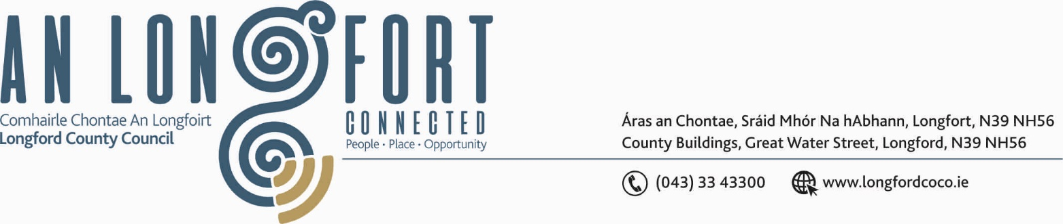

GRANARD MUNICIPAL DISTRICT

Corporate Affairs,
Please note Venue Aras an Chontae,
Council Chamber, Aras an Chontae. LONGFOIRT.

14th March 2019.

To: Each Member of Granard Municipal District.

Dear Member,

You are requested to attend Meeting of Granard Municipal District to be held in
the Council Chamber, Aras an Chontae, Longford on Friday, 22nd March 2019 at 3.30 p.m. to transact business, as set out on the Agenda hereunder.

Yours sincerely,
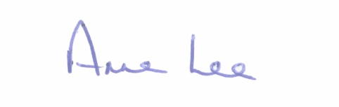

_______________
Anne Lee,
Meetings Administrator.

AGENDA

Prayer before meeting.

1. Confirmation of the Minutes of Granard Municipal District Meeting held on the 22nd January 2019– copy enclosed.

2. Matters arising from Minutes.

3. Area Engineer’s Progress Report.

4. Consideration of Schedule of Granard Municipal District Works -
report enclosed.

5. Consideration of applications for funding under the 2019 Community Grant Support Scheme - list enclosed.

6. Notices of Motions, submitted by Councillors, as listed hereunder -

Councillor Martin Mulleady.

“I request that €2,000.00 to be allocated to the Drumlish Christmas Lights Committee to upgrade all the lights to LED lights.”

::::::::::::::::::::::::::::::::::::

